Supplementary Information:
Sustaining Dryland Vegetation and Soil Health through Saline Water Irrigation Strategies

Futian Ren ^{1, 3}, Guang Yang ^{1, 2,} *, Hao Tian ^{1, 2}, Muhammad Arsalan Farid ^{1, 2}, Yi Li ⁴, Xinlin He ^{1, 2}, Yongli Gao ⁵, Fadong Li ⁶, Lianqing Xue ⁷
¹ College of Water Conservancy & Architectural Engineering, Shihezi University, Shihezi, 832003, China; mikeyork@163.com (G.Y.); haotian1996_china@163.com (H.T.); engr.arsalan.406@gmail.com (M.A.F);
² Key Laboratory of Cold and Arid Regions Eco-Hydraulic Engineering of Xinjiang Production & Construction Corps, Shihezi, 832003, China; hexinlin2002@163.com (X.H.)
³ School of the Environment, Nanjing University, Xianlin Campus, Nanjing, 210023, China; renfutiann@163.com (F.R.)
⁴ College of Water Resources and Architectural Engineering, Northwest Agriculture and Forestry University, Yangling, 712100, China; liyi@nwafu.edu.cn (Y.L.)
⁵ Department of Earth and Planetary Sciences, University of Texas at San Antonio, TX 78249, USA; yongli.gao@utsa.edu (Y.G.)
⁶ Institute of Geographic Sciences and Natural Resources Research, Chinese Academy of Science, Beijing, 100101, China; lifadong@igsnrr.ac.cn (F.L.)
⁷ Hydrology and Water Resources College, Hohai University, Nanjing, 210024, China; lqxue@hhu.edu.cn (L.X.)

* Corresponding author: Guang Yang (mikeyork@163.com)

This file includes:
Pages: S1-S15, Figures: S1-S3, Tables: S1-S5, Texts: S1-S2
Supplementary Information
Figure | Page No.
Figure S1 Distribution of daily mean temperature and daily rainfall in the study area during 2019–2020 | S4
Figure S2 Soil-texture triangle with colored points indicating the textures obtained according to the clay-silt-sand fractions along the soil profile at the experimental site | S5
Figure S3 Comparison between simulated and measured soil water content and EC at depths of 20, 40, and 60 cm during the independent validation period (2020) under different irrigation-water salinity treatments | S14
Table
Table S1 Initial chemical properties in 0–100 cm soil layer in 2019–2020 | S6
Table S2 Irrigation scheduling for the Haloxylon ammodendron test period | S7
Table S3 Parameters of water absorption by roots | S11
Table S4 Solute transport parameters | S12
Table S5 Model performance during calibration (2019) and independent validation (2020) under different irrigation water salinity treatments. | S15
Contents
Text S1 Construction of experimental plots | S8
Text S2 Mathematical model and numerical simulation model of soil water and salt transport | S10

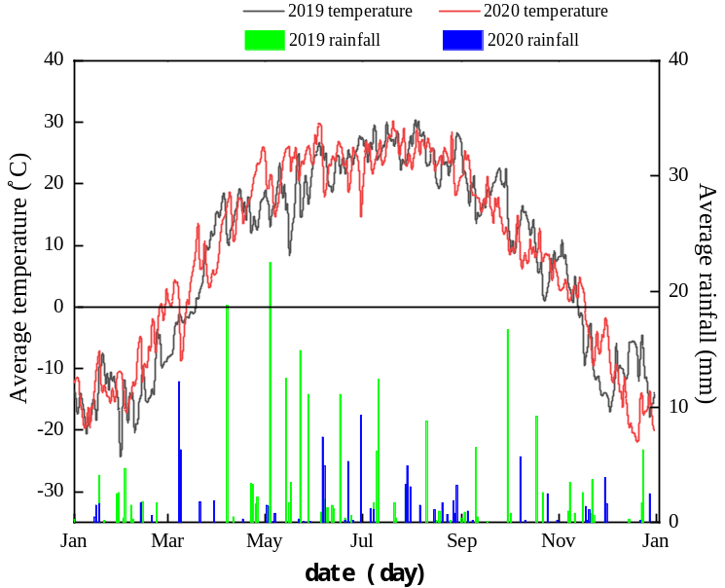
Figure S1 Distribution of daily mean temperature and daily rainfall in the study area during 2019–2020.
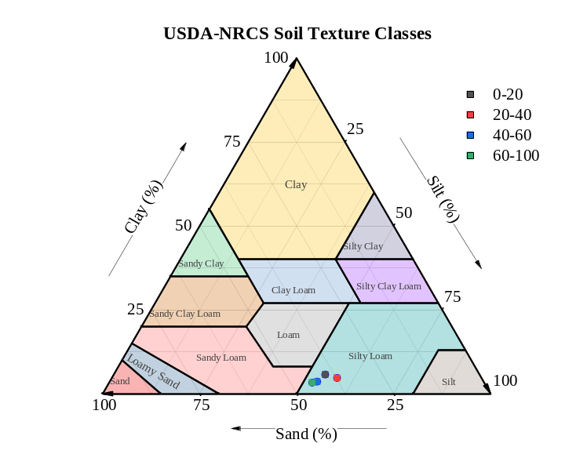
Figure S2 Soil-texture triangle with colored points indicating the textures obtained according to the clay-silt-sand fractions along the soil profile at the experimental site.

Table S1 Initial chemical properties in 0–100 cm soil layer in 2019–2020.
Treatment |  | K⁺  g·kg⁻¹ | Na⁺  g·kg⁻¹ | Ca²⁺  g·kg⁻¹ | Mg²⁺  g·kg⁻¹ | Cl⁻  g·kg⁻¹ | SO₄²⁻  g·kg⁻¹ | CO2- 3  g·kg⁻¹ | HCO- 3g·kg⁻¹ | EC  dS· m⁻¹ | pH
2019 | A | 0.125 | 0.733 | 0.0597 | 0.0364 | 0.699 | 0.033 | 0.191 | 0.000 | 0.450 | 8.40
2019 | B | 0.120 | 0.667 | 0.0597 | 0.0364 | 0.167 | 0.019 | 0.145 | 0.022 | 0.750 | 8.50
2019 | C | 0.070 | 0.715 | 0.0597 | 0.0364 | 0.105 | 0.026 | 0.239 | 0.000 | 0.580 | 8.53
2019 | D | 0.067 | 0.721 | 0.0597 | 0.0485 | 0.270 | 0.048 | 0.286 | 0.000 | 0.820 | 8.61
2019 | E | 0.055 | 0.609 | 0.0597 | 0.0121 | 0.470 | 0.032 | 0.686 | 0.015 | 0.690 | 8.62
 | A | 0.129 | 0.741 | 0.0620 | 0.0388 | 0.701 | 0.040 | 0.200 | 0.001 | 0.490 | 8.31
 | B | 0.128 | 0.660 | 0.0627 | 0.0387 | 0.181 | 0.022 | 0.150 | 0.021 | 0.760 | 8.33
2020 | C | 0.077 | 0.721 | 0.0621 | 0.0391 | 0.112 | 0.029 | 0.241 | 0.004 | 0.640 | 8.41
 | D | 0.069 | 0.731 | 0.0625 | 0.0398 | 0.271 | 0.051 | 0.291 | 0.007 | 0.890 | 8.68
 | E | 0.061 | 0.618 | 0.0629 | 0.0218 | 0.490 | 0.033 | 0.698 | 0.017 | 0.710 | 8.71

Table S2 Irrigation scheduling for the Haloxylon ammodendron test period.
Irrigation date | Irrigation quota in 2019 (mm) | Irrigation quota in 2019 (mm)
15 May | 34.5 | 34.5
05 Jun | 34.5 | 34.5
25 Jun | 34.5 | 34.5
16 Jul | 34.5 | 34.5
06 Aug | 34.5 | 34.5
26 Aug | 34.5 | 34.5
16 Sept | 34.5 | 34.5
07 Oc | 34.5 | 34.5

Text S1 Construction of experimental plots
To examine the effects of saline water irrigation on soil physico-chemical properties and the growth of Haloxylon ammodendron, fifteen experimental plots were constructed following standardized procedures. The detailed construction process is described below:
Excavation and plot isolation
Each plot was excavated to a depth of 200 cm, with dimensions of 2 m (width) × 3 m (length) × 2 m (depth). A 30 cm gravel filter layer was placed at the bottom of each plot, and cement curbs were installed along the boundaries to minimize lateral water and salt movement between adjacent plots.
Soil collection and characterization
The backfilling soil was collected from farmland with more than 20 years of cultivation history. Prior to backfilling, the original soil was characterized for its physico-chemical properties, including particle size distribution, grain composition, porosity, dry bulk density, and soil moisture content, in order to conserve the original soil profile characteristics.
Backfilling method
The dry heap method was used for backfilling. Each soil layer was filled in increments of 10–15 cm. The weight (W) of each soil layer was calculated as:
W=V⋅γ⋅ (1+S)
where V is the volume of backfill soil per layer, γ is the dry bulk density of the original soil, and S is the soil moisture content of the original soil.
Compaction
After placing the calculated soil weight (W), each soil layer was compacted using a mechanical compactor to match the height of the original soil profile. This ensured that the dry bulk density and porosity of the backfilled soil were approximately consistent with those of long-term cultivated soils.
Field preparation and planting
The plots were originally constructed prior to 2010 and used for field cultivation for several years. Since 2018, saline water irrigation experiments with Haloxylon ammodendron have been conducted under mulched drip irrigation.
Experimental objectives
The saline irrigation experiment was designed to address two main questions:
(1) What is the appropriate salinity level of irrigation water that supports the growth and physiological performance of Haloxylon ammodendron under mulched drip irrigation?
(2) How different salinity levels affect soil physico-chemical properties as well as the physiology and growth process of Haloxylon ammodendron.

Text S2 Mathematical model and numerical simulation model of soil water and salt transport

2.1 Soil water and solute transport model
Saline water was supplied through a drip irrigation system. During irrigation, initially three-dimensional wetting patterns developed around individual emitters. As irrigation continued, adjacent wetting fronts merged along the drip line, allowing water and solute transport to be approximated using a two-dimensional vertical cross-section perpendicular to the drip line.
The HYDRUS-2D simulation domain was 200 cm deep and 200 cm wide. Each soil layer was assumed to be internally homogeneous and isotropic, while vertical heterogeneity was represented using layer-specific hydraulic parameters. Variably saturated water flow was described using the modified Richards equation, solute transport was simulated using the convection–dispersion equation, and root water uptake was represented using the Feddes pressure-head reduction function.
The model simulated water and solute transport throughout the entire soil profile. The 0–60 cm interval was subsequently used as the primary salinity-assessment layer because it encompassed the monitored depths and the soil interval in which irrigation-induced water and salt redistribution was directly characterized. It was not assumed to represent the complete rooting depth of HA. The model geometry and boundary conditions are shown in Figure 3.

2.2 Model parameters and boundary conditions
Initial soil hydraulic parameters were estimated using the Rosetta module implemented in HYDRUS-2D based on the measured soil texture, bulk density, and saturated water content. Soil water retention and hydraulic conductivity were described using the Mualem–van Genuchten model. The soil profile was divided into the 0–30, 30–60, 60–100, and 100–170 cm layers, with layer-specific hydraulic parameters assigned to account for vertical soil heterogeneity.
The initial hydraulic and solute-transport parameters were calibrated against the 2019 field observations of soil water content and EC. After calibration, the resulting parameter set was fixed and used without further adjustment for independent validation using the 2020 dataset. The final calibrated hydraulic parameters are reported in Table 2 of the main manuscript. Longitudinal and transverse dispersivities used for solute transport are provided in Table S4.
Root water uptake was represented using the Feddes pressure-head reduction function, with P0, POpt, P2H, P2L, and P3 specified as shown in Table S3. These parameters describe the response of root water uptake to soil matric-water stress rather than salinity stress. Species-specific osmotic-stress parameters for HA were not independently parameterized in the present model. Therefore, salinity was represented through solute transport and accumulation, and the model was used to evaluate relative soil salinization risks among irrigation treatments rather than to derive a physiological salinity-tolerance threshold for HA.
An atmospheric boundary condition was assigned to the soil surface using the measured precipitation, irrigation, and evaporation data for each simulation year. Irrigation-water solute concentrations were prescribed according to the measured salinity of the corresponding irrigation treatment. The lateral boundaries were specified as no-flow boundaries, and the lower boundary was defined as free drainage because groundwater was substantially deeper than the simulated soil profile.
Table S3 Parameters of water uptake by roots.
Parameter | Numerical value
P0/cm | -10
POpt/cm | -25
P2H/cm | -200
P2L/cm | -600
P3/cm | -8000
Note: P0 and Popt define the wet-end reduction and optimal root-water-uptake range. P2H and P2L represent the limiting pressure heads under high and low potential transpiration rates, respectively, whereas P3 represents the pressure head below which root water uptake ceases. These parameters describe water stress and do not represent HA-specific salinity-stress parameters.
Table S4 Solute transport parameters.
Parameter | Numerical value
Number of solutes | 1
Transverse dispersion/cm | 4
Longitudinal dispersion/cm | 15
Molecular diffusivity coefficient /(cm²·d⁻¹) | 25

2.3 Model calibration and validation framework
Model calibration and validation were conducted using temporally independent datasets from two growing seasons. Field observations collected during the 2019 growing season were used for model calibration, whereas observations from the 2020 growing season were reserved for independent temporal validation.
Measured gravimetric water content was converted to volumetric water content using the corresponding soil bulk density before comparison with HYDRUS-2D simulations.
During calibration, the initial soil hydraulic and solute-transport parameters were adjusted within physically reasonable ranges by comparing simulated and measured soil water content and EC at the 20, 40, and 60 cm monitoring depths. After satisfactory calibration was achieved, the resulting parameter set was fixed. The model was then applied to the 2020 growing season without further parameter adjustment. Year-specific initial soil conditions, irrigation inputs, irrigation-water salinity, precipitation, and evaporation were prescribed according to the corresponding field observations for each simulation year.
Model performance was evaluated separately for soil water content and EC using the coefficient of determination (R²), Nash–Sutcliffe efficiency (NSE), and root mean square error (RMSE). R² was used to characterize the agreement between simulated and observed temporal variations, NSE was used to evaluate predictive efficiency relative to the observed mean, and RMSE quantified the magnitude of prediction errors. Because RMSE is dependent on the magnitude and unit of the evaluated variable, model performance was assessed jointly using R², NSE, and RMSE rather than using a single universal acceptance threshold. Performance statistics were calculated separately for each irrigation treatment and monitoring depth.

2.4 Model calibration and independent validation
The HYDRUS-2D model was calibrated using soil water and salinity observations collected during the 2019 growing season. Model performance was evaluated at monitoring depths of 20, 40, and 60 cm under each of the five irrigation-water salinity treatments. During calibration, R² for soil water content ranged from 0.648 to 0.994, NSE from 0.512 to 0.992, and RMSE from 0.338 to 0.855. For EC, R² ranged from 0.615 to 0.990, NSE from 0.522 to 0.987, and RMSE from 0.143 to 0.588 (Table S5).
After completion of the 2019 calibration, all calibrated soil hydraulic and solute-transport parameters were fixed and applied without further adjustment to the 2020 growing season for independent temporal validation. Only year-specific initial and forcing conditions were updated using the corresponding 2020 observations.
During independent validation, R² for soil water content ranged from 0.568 to 0.990, NSE from 0.375 to 0.989, and RMSE from 0.364 to 0.938. For EC, R² ranged from 0.534 to 0.983, NSE from 0.438 to 0.983, and RMSE from 0.153 to 0.642. The complete treatment- and depth-specific statistics for both calibration and validation are summarized in Figure S3 and Table S5.
Model performance varied among soil depths and treatments, with comparatively larger discrepancies occurring at some deeper monitoring locations, particularly at 60 cm. Nevertheless, the independent 2020 validation retained broadly comparable performance to the 2019 calibration without parameter readjustment, supporting the temporal transferability of the calibrated model for comparing soil water and salt dynamics among irrigation treatments.
Because calibration and validation covered only two growing seasons, subsequent long-term simulations were interpreted as scenario-based projections of relative soil salinization risk rather than precise forecasts of future soil water and salt conditions.
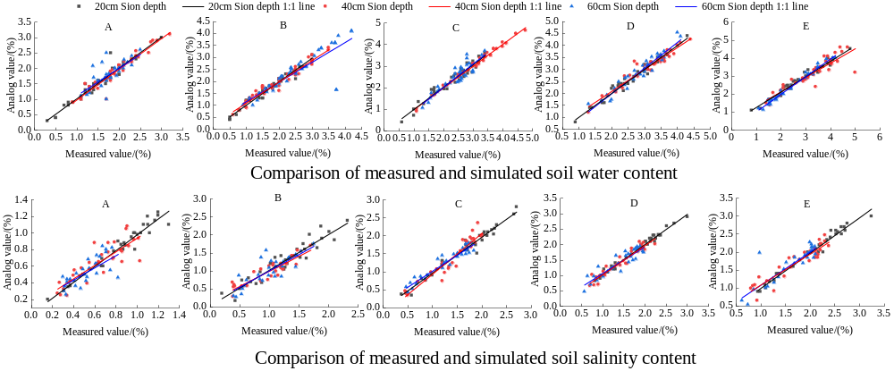
Figure S3 Comparison between simulated and measured soil water content and EC at depths of 20, 40, and 60 cm during the independent validation period (2020) under different irrigation-water salinity treatments.
Table S5 Model performance during calibration (2019) and independent validation (2020) under different irrigation water salinity treatments.
 |  | 2019 calibration |  |  |  |  |  | 2020 validation
Treatment | Soil layer(cm) | GWC |  |  | EC |  |  | GWC |  |  | EC
Treatment | Soil layer(cm) | R² | NSE | RMSE | R² | NSE | RMSE | R² | NSE | RMSE | R² | NSE | RMSE
A | 20 | 0.951 | 0.944 | 0.548 | 0.968 | 0.965 | 0.279 | 0.927 | 0.920 | 0.594 | 0.955 | 0.953 | 0.302
A | 40 | 0.944 | 0.936 | 0.526 | 0.764 | 0.742 | 0.218 | 0.921 | 0.914 | 0.571 | 0.713 | 0.699 | 0.235
A | 60 | 0.648 | 0.512 | 0.338 | 0.615 | 0.522 | 0.143 | 0.568 | 0.375 | 0.364 | 0.534 | 0.438 | 0.153
B | 20 | 0.988 | 0.981 | 0.652 | 0.924 | 0.913 | 0.508 | 0.978 | 0.967 | 0.710 | 0.899 | 0.888 | 0.552
B | 40 | 0.971 | 0.966 | 0.684 | 0.881 | 0.872 | 0.344 | 0.954 | 0.952 | 0.748 | 0.842 | 0.842 | 0.373
B | 60 | 0.786 | 0.758 | 0.803 | 0.752 | 0.71 | 0.341 | 0.727 | 0.700 | 0.878 | 0.696 | 0.629 | 0.369
C | 20 | 0.963 | 0.954 | 0.699 | 0.979 | 0.975 | 0.573 | 0.945 | 0.933 | 0.762 | 0.968 | 0.963 | 0.625
C | 40 | 0.994 | 0.992 | 0.807 | 0.941 | 0.915 | 0.516 | 0.990 | 0.989 | 0.880 | 0.917 | 0.863 | 0.563
C | 60 | 0.866 | 0.821 | 0.522 | 0.945 | 0.937 | 0.399 | 0.829 | 0.741 | 0.567 | 0.923 | 0.921 | 0.434
D | 20 | 0.982 | 0.978 | 0.699 | 0.990 | 0.987 | 0.522 | 0.970 | 0.969 | 0.762 | 0.983 | 0.983 | 0.571
D | 40 | 0.947 | 0.941 | 0.635 | 0.936 | 0.930 | 0.402 | 0.920 | 0.913 | 0.689 | 0.915 | 0.914 | 0.437
D | 60 | 0.951 | 0.939 | 0.642 | 0.872 | 0.861 | 0.378 | 0.927 | 0.900 | 0.696 | 0.840 | 0.838 | 0.411
E | 20 | 0.981 | 0.971 | 0.781 | 0.988 | 0.985 | 0.588 | 0.969 | 0.955 | 0.850 | 0.979 | 0.978 | 0.642
E | 40 | 0.865 | 0.852 | 0.855 | 0.898 | 0.889 | 0.454 | 0.824 | 0.815 | 0.938 | 0.863 | 0.862 | 0.494
E | 60 | 0.990 | 0.988 | 0.799 | 0.835 | 0.812 | 0.425 | 0.982 | 0.982 | 0.869 | 0.791 | 0.765 | 0.460
Mean |  | 0.922 | 0.902 | 0.666 | 0.886 | 0.868 | 0.406 | 0.895 | 0.868 | 0.725 | 0.855 | 0.836 | 0.441

